Project Proposal

Drake Kayla, Onitiju Taiwo, Khatoon Fehmida, Antonenko Vadym

CAP6768 Data Analytics

October 30th 2025

Team Members
- Drake Kayla
- Taiwo Onitiju
- Khatoon Fehmida
- Antonenko Vadym

Dataset Selection
For this project, we plan to utilize the Retail Store Daily Sales dataset (data_analytics_retail.csv), which contains 90 days of daily sales data from June 2025 to August 2025.

Problem Statement
The retail store experiences significant revenue fluctuations, hypothetically driven by weekend patterns. Our goal is to:
- Classify each day as High/Low revenue to optimize daily staffing and inventory decisions.
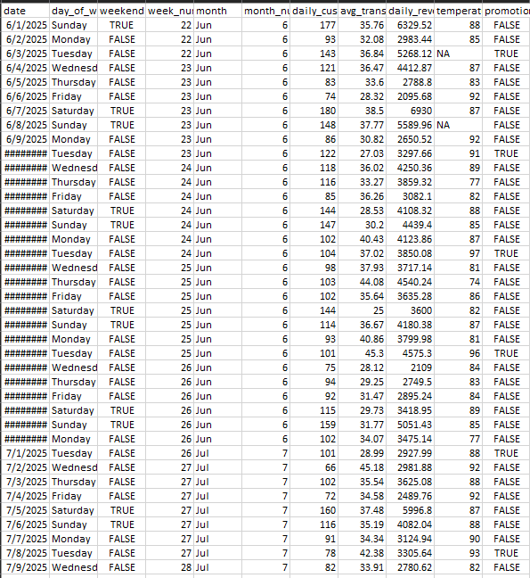
- Forecast next week's revenue to support weekly planning and promotional budgeting.

Problem Type
- Binary Classification: High Revenue (1) vs Low Revenue (0) using median as the cutoff.
- Forecasting: Time series prediction of daily revenue for the next 7 days.
Proposed Solution Methods
- Classification Approach:
- Main Features: weekend, daily_customers, promotion, day_of_week.
- Models:
Logistic Regression (interpretable baseline).
Random Forest (capture non-linear patterns like weekend effects).
XGBoost (handling feature interactions).
- Forecasting Approach:
- Time Series Models:
SARIMA (capture weekly seasonality observed in data).
Prophet (handle trends + weekly patterns).
- Feature-Based Approach: Regression with lagged variables and calendar features
- Additional Techniques:
Feature importance analysis to identify key drivers.
Time-based validation (train on first 80 days, test on last 10 days).
Business impact analysis of classification accuracy.

Expected Outcomes
- Staffing optimization: Better align workforce with expected daily revenue.
- Inventory management: Prepare for high-volume days.
- Promotion planning: Schedule promotions on days with highest impact potential.
- Estimated cost savings: 15-20% reduction in overstaffing/understaffing costs.

